**Memory Organization**

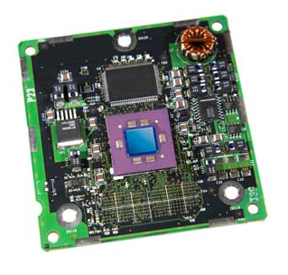

**Computer Memory**

**A memory unit is an essential component in any digital computer since it is needed for storing programs and data.**

**Primary Memory**

**The primary memory is also known as internal memory, and this is accessible by the processor straightly. This memory includes main memory, cache memory, as well as CPU registers.**

**Secondary Memory**

**The secondary memory is also known as external memory, and this is accessible by the processor through an input/output module. This memory includes an optical disk, magnetic disk, and magnetic tape.**

**The total memory capacity of a computer can be visualized by hierarchy of components.**

**Why memory hierarchy?**

* **To provide CPU with necessary data and instructions as quickly as possible.**
* **Memory distributing is simple and economical.**
* **Data can be spread all over.**

**The overall goal of using memory hierarchy is to obtain the highest possible average access speed while minimizing the total cost of entire memory system.**

**Memory Hierarchy**

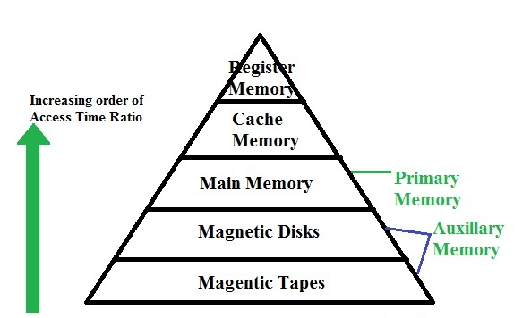

**Registers**

**Registers are a type of computer memory used to quickly accept, store, and transfer data and instructions that are being used immediately by the CPU. The registers used by the CPU are often termed as Processor registers.**

**Cache Memory**

**A special very –high-speed memory called a cache is sometimes used to increase the speed of processing by making current programs and data available to the CPU at a rapid rate. The cache memory is very small , relatively expensive and has very high access speed.**

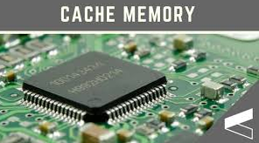

**Main Memory**

**The memory unit that establishes direct communication with the CPU is called Main Memory. Only programs and data currently needed by the processor reside in main memory.**

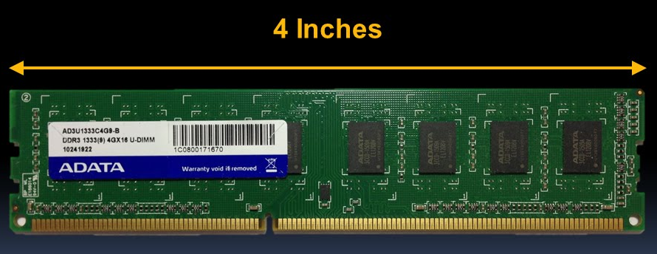

**Auxiliary Memory**

**The memory units that provide backup storage are called Auxiliary Memory. They are used for storing system programs, large data files and other backup information. The most common auxiliary memory devices used in computer systems are magnetic disks and tapes. Programs not currently needed in main memory are transferred into auxiliary memory to provide space for currently used programs and data.**

**Magnetic Disks**

**The magnetic disks used as backup storage. Magnetic disk is an example of Secondary memory.**

**Secondary memory (secondary storage) is non-volatile. Examples are hard disks, floppy disks, CDs, DVDs, flash memory, etc.**

**A magnetic disk is a storage device that uses a magnetization process to write, rewrite and access data.**

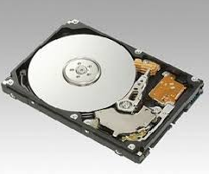

**Magnetic Tape**

**A magnetic tape drive is a storage device that makes use of magnetic tape as a medium for storage. Magnetic tapes used to store removable files.**

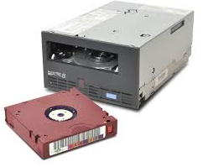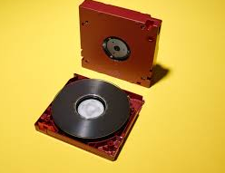

**A company can back up its data to tapes, remove them, and send by courier to off-site storage. This is a very important step for disaster recovery.**